Ruttvik Aron
[Company Name] | [Company Address]
AI-Driven Natural Language Rule Engine for Healthcare Data Management

Executive Summary
Healthcare organizations face persistent challenges in managing complex data rules essential for managing their operations. Traditional rule authoring is technical, slow, and heavily reliant on specialized teams, creating operational bottlenecks and increased costs. This paper describes an AI-powered natural language rule engine designed to empower non-technical users with intuitive, conversational interactions for rule creation and refinement. By combining advanced natural language processing (NLP), domain-specific knowledge graphs, and interactive visualizations, the approach significantly accelerates rule development cycles, reduces dependency on IT resources, and ensures regulatory compliance---all while delivering substantial cost savings and operational efficiency. This whitepaper outlines the context and scale of the rule-authoring challenge in healthcare, analyzes limitations of current practices and tools, and describes how a Natural Language to Rule Engine (NL-to-Rule Engine) can address these constraints. It also summarizes business value drivers and illustrates impact through a representative case study.

Introduction
Healthcare organizations face significant challenges in managing comprehensive rule sets that govern data quality, regulatory compliance, and operational workflows. These rules range from simple data normalization (such as phone number standardization) to multi-layered eligibility criteria involving state-specific Medicaid regulations and Centers for Medicare & Medicaid Services (CMS) guidelines.
Typical Rule Volume & Impact:
- Rule libraries often exceed 100,000 individual rules.
- Rules affect patient access, network participation, billing accuracy, and compliance audits.
- Errors or delays in rule authoring risk financial penalties, network disruption, and reduced patient service quality.
Workflow Limitations:
Current rule authoring systems require highly technical expertise. Business analysts, despite deep domain understanding, cannot directly author or modify rules. As a result, they rely heavily on IT teams or specialized Business Rules Units (BRU) , creating bottlenecks, high costs, and sluggish turnaround.
Rule authoring traditionally falls into three categories:
- Simple Rules: Direct if-then logic with explicit outputs
- Intermediate Rules: Known inputs but uncertain outputs requiring interpretation
- Complex Rules: Multi-condition, database lookups, and domain-specific logic
Despite their complexity, even simple and intermediate rules frequently mandate specialized technical support. HiLabs analysis reveals that even simple and intermediate rules often require intervention from specialized BRUs due to insufficiently accessible tools for non-technical users.
Problem Statement
Detailed User Pain Analysis Problem Statement -
Healthcare organizations today grapple with an overwhelming reliance on specialized technical teams for even the simplest rule authoring tasks. This dependency incurs costs not only in terms of direct effort but also through delayed operational insights, heightened compliance risks, and reduced agility in responding to the fast-evolving payer, provider, and regulatory landscape.
Traditional Rule Authoring Bottlenecks -
- Dependency on BRUs: Analysts cannot independently create or modify rules, creating backlogs and delaying deployment.
- Batch editing bottlenecks -
Editing multiple rules at once still requires extensive BRU intervention, inflating support loads.
- Conflict checking complexities -
Identifying conflicting or redundant rules without automated support extends turnaround times. Impact - Higher operational costs rising into millions annually.
Impact -
- Higher operational costs rising into millions annually.
- Slower response to regulatory changes impacting compliance and business agility.
- Inability of analysts to exercise full control over their domain-specific logic.
Expanded View of User Challenges -
While these teams possess the technical expertise necessary for rule creation, their limited capacity creates a critical bottleneck:
- Limited Bandwidth
- Skill Silos
- Communication Gaps
These dependencies inflate delivery timelines significantly and increase operational costs due to prolonged manual intervention.

Inefficient batch editing and rule modification -
In practice, healthcare data environments require periodic bulk updates to rules, such as adapting to regulatory changes or correcting systemic data issues. However:
- High support overhead: Even when clients delegate rule editing to their own UI teams, many “simple” changes still require BRU involvement due to insufficient user-friendly tooling.
- Process fragmentation: Editing multiple rules across different systems or modules becomes fragmented, with little automation to coordinate batch updates or version synchronizations.
- Error proneness: Manual edits across hundreds or thousands of rules amplify opportunities for human error, inconsistencies, or overlooked conflicts.
This inefficiency causes operational strain and delays regulatory compliance and network updates.
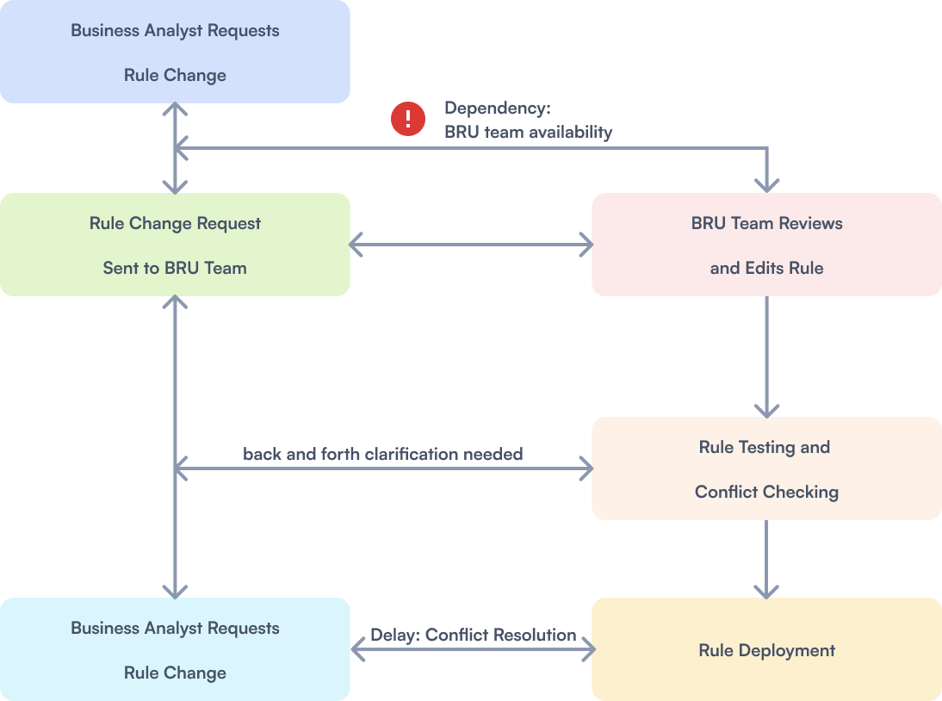
[Image Caption] Diagram: Process flow showing traditional rule editing bottleneck and delays in deploying updates

Platform Type | Features | Limitations
General-Purpose Engines | Workflow designers, no natural language input | High learning curve for analysts
Healthcare-Specific Tools | Domain-specific but non-customizable | Vendor lock-in, limited agility
HiLabs NL Rule Engine | Plain English input, AI-assisted creation | Enables direct analyst access

Time-consuming conflict detection and resolution -
Healthcare rules often interact in complex ways. New or modified rules may inadvertently conflict with existing logic, risking data inaccuracies or compliance violations. The conventional approach to conflict management suffers from:
- Manual validation: Identifying overlapping or contradictory rules typically involves painstaking manual review by experts.
- Delayed feedback loops: Long wait times for conflict detection extend rule deployment cycles, slowing organizational agility.
- Increased operational risk: Undetected conflicts can lead to compliance breaches, billing errors, or patient access issues.
The lack of automated support and real-time feedback significantly heightens operational risk and resource demands.

Objective Recommendation
Given these constraints, healthcare organizations benefit from approaches that:
- Enable domain experts to author and refine rules directly, without depending on scarce technical resources for simple and intermediate logic.
- Provide intuitive interfaces, including natural language interaction and visual representations, so that rule logic is understandable and reviewable by both technical and non-technical stakeholders.
- Incorporate automated validation and conflict detection, reducing manual review effort and lowering the risk of inconsistent or contradictory rules.
- Support governance and auditability, ensuring that regulatory expectations can be met even as rule volumes and complexity increase.
A Natural Language to Rule Engine (NL-to-Rule Engine) operationalizes these principles by translating plain English instructions into executable rule logic while maintaining transparency, reviewability, and control.

HiLabs Approach

HiLabs Natural Language to Rule Engine (NL-to-Rule Engine) directly addresses this bottleneck. Combining AI-powered natural language processing with an intuitive, user-focused design, the solution empowers even non-technical analysts to author, validate, and publish healthcare data quality rules in plain English. What was historically a time-consuming, expert-heavy, and opaque process can now become more efficient, transparent, and collaborative.
The approach follows an AI-first and user-first philosophy designed to minimize analyst dependencies, reduce error rates, and dramatically accelerate speed to deployment—enabling healthcare organizations to adapt rapidly while maintaining data integrity and regulatory compliance.

Results/Proof Points
Central to the solution is a chatbot-style assistant that interprets user inputs expressed in everyday language. Business analysts can simply type instructions such as: “Flag providers with missing NPI in Florida whose specialty is cardiology.”
The engine then translates this natural language input into structured logic and generates executable rules. This removes the technical barrier to rule creation while preserving the rigor and specificity required in healthcare data environments, enabling business analysts to engage directly in rule authoring.

Iterative Prompts and Refinements
The NL-to-Rule Engine supports an interactive, conversational refinement cycle that allows users to evolve rules through dialogue. For example:
- User: “Now include nurse practitioners.”
- Assistant: “Updated rule: Include providers with specialty cardiology and nurse practitioners.”
This back-and-forth reduces the rework typically needed when instructions are handed off between business users and technical teams. The process remains collaborative and flexible while reflecting the underlying business intent.

Dual Rule Visualization
The system presents rules in two synchronized formats to support different stakeholder needs:
- Structured Text View: Provides detailed, logic-based conditions understandable to analysts with technical familiarity.
- Workflow (Flowchart) View: Offers a visual sequence of rule operations for non-technical business users and executives.
This dual representation helps align understanding between technical and business stakeholders so rule logic can be reviewed and validated before publication. Flexible Editing and Attribute Configuration
Users can adjust rule parameters or configure attributes directly within the interface without rewriting entire rules. This decreases friction and allows analysts to iteratively maintain rule sets, reducing reliance on BRUs for routine updates.
By uniting AI-powered language understanding with user-centered design, the NL-to-Rule Engine supports a more accessible and collaborative rule management practice. This empowers healthcare organizations to respond swiftly to evolving requirements, optimize resource allocation, and manage data quality and compliance with greater efficiency.
Strategic Business Value
For Users  Reduced dependency on BRUs  By enabling business analysts and operational staff to author and refine simple and medium-complexity rules independently, the solution reduces reliance on specialized BRUs. Technical resources can focus on higher-value platform enhancements, reducing operational bottlenecks.  Faster turnaround with conversational iterations  Conversational, iterative rule refinement accelerates cycles from ideation to deployment. Users can adjust rules through natural language prompts, helping them respond faster to emerging business or regulatory needs.  Greater confidence via built-in checks and visualizations  Integrated conflict detection, logic validation, and dual rule visualization gives users immediate feedback. This transparency supports trust in rule integrity and reduces the likelihood of costly errors or rework. | For Organizations  Cost efficiency  By implementing the NL-to-Rule Engine, organizations can realize cost efficiencies by reducing the time and resources required for rule development and maintenance. The solution streamlines rule deployment, decreases reliance on specialized technical teams, and enables business users to manage rules independently, all of which contribute to lowering operational expenses.  Accelerated speed to market  The platform compresses rule implementation timelines from months to weeks, enabling healthcare entities to adapt more rapidly in a shifting regulatory and business environment.  Compliance assurance  Every authored rule is transparent, validated, and audit-ready, supporting governance frameworks and regulatory oversight. This compliance confidence minimizes risk exposure and bolsters stakeholder trust.

These improved outcomes empower healthcare organizations to optimize budgets while maintaining high standards of data governance. For detailed analysis and quantitative evidence, please refer to the case study section following this.

Case Study: Achieving Cost Efficiency and Operational Agility with the NL-to-Rule Engine
Healthcare organizations managing large-scale rule libraries often face costly and time-intensive challenges in rule development, validation, and deployment. This case study illustrates how adopting the NL-to-Rule Engine can reduce effort, cost, and cycle times while supporting compliance and responsiveness.
Background
A healthcare organization managing over 110,000 data quality and compliance rules sought to reduce operational costs and accelerate time-to-market for rule deployments. Traditionally, rule management required manual coding by specialized BRUs, resulting in prolonged turnaround times and significant resource overhead.
This case study presents a before-and-after comparison within this environment.

Before NL-to-Rule
Traditionally, healthcare data quality rules are authored and maintained through technical workflows requiring extensive involvement from BRUs. Business analysts often lack tools to independently create or modify rules, leading to:
- Excessive dependency on BRU resources, even for simple rule changes.
- Slow turnaround times, where rule creation and validation could take weeks or months.
- High costs, driven by thousands of hours in manual effort.

Case data (for 110,000 rules):
- 50,000 analyst days required
- 4,166 months of effort
- $58 million in costs
This approach is not scalable, especially as payers and providers face continual regulatory changes and growing complexity in healthcare data.

After NL-to-Rule
By introducing the NL-to-Rule Engine, the process shifted from manual scripting and BRU dependency to a conversational, AI-assisted experience. Analysts could author rules themselves, validate them, and publish them with greater autonomy.
Case data (for 110,000 rules):
- 10,000 analyst days required
- 833 months of effort
- $3.75 million in costs

Aspect | Before Implementation | After Implementation
Rule Development Effort | Approximately 50,000 manual effort-days required, relying heavily on specialized BRUs for rule creation, modification, and conflict resolution. | Reduced to approximately 10,000 effort-days due to business users authoring and refining rules independently through natural language interaction.
Operational Costs | Estimated annual expenses around $58 million, driven by manual processes, technical dependencies, and lengthy review cycles. | Costs decreased dramatically to approximately $3.75 million annually, reflecting streamlined workflows and reduced reliance on technical teams.
Turnaround Time | Rule deployment and updates took several months or longer, affecting agility and compliance responsiveness. | Rule deployments accelerated to weeks, enabling more rapid adaptation to changing requirements.
User Empowerment & Collaboration | Business analysts were unable to create or modify rules without technical intermediaries, creating bottlenecks and miscommunication risks. | Business users author and iteratively refine rules via conversational prompts, improving collaboration and reducing misinterpretation.
Compliance and Quality Assurance | Conflict detection and error checking were manual and slow, increasing risk of non-compliance and data integrity issues. | Built-in validation and dual visualization provide conflict detection and improved rule quality, enhancing confidence in compliance.

This resulted in
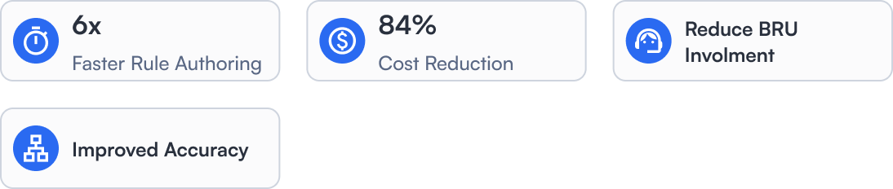

Comparative Landscape: Other Market Offerings
The healthcare data rules ecosystem features a range of business rule management tools (BRMs) designed to streamline complex logic creation. Many solutions were developed for general-purpose enterprise settings rather than the regulated, and data-heavy use cases in U.S. healthcare.
This section benchmarks the NL-to-Rule Engine against three prominent rule-authoring platforms. While these solutions provide capabilities in workflow design and logic validation, they do not combine an AI-driven natural-language interface with healthcare domain specificity in the same way.

Market Landscape Overview
Competitors | Target User | Core Strength | Key Limitation
Rules Engine Product Company #1 | Business and IT users | Visual rule builder and business dictionary | Limited AI support, unclear conflict management
Rules Engine Product Company #2 | Technical business users | Role-based access control (RBAC), review flows, and attribute editing | No healthcare focus, minimal natural language or AI interaction
Rules Engine Product Company #3 | Developers and analysts | AI-assisted decision tables, testing, and debugging | Steep learning curve, not domain-specific
HiLabs Rules Engine | Healthcare data analysts | AI-assistive natural language input, healthcare specificity, dual visualization | Heavy focus on healthcare payer operations

Comparative Feature Analysis
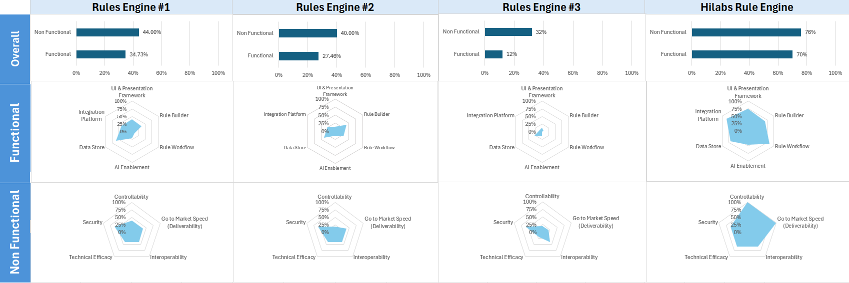
HiLabs NL-to-Rule Engine Differentiation
HiLabs NL-to-Rule Engine combines AI innovation with healthcare specialization. While competitors prioritize either usability or flexibility, this approach focuses on both—with rule authoring designed to be accessible, collaborative, and contextually aligned with healthcare rule management needs.

Key Differentiators
- Plain English input that enables intuitive rule creation without technical syntax.
- Healthcare-specific logic models oriented toward provider data cleaning, eligibility checks, and regulatory compliance.
- AI-guided interactions where a chatbot interface supports ongoing rule refinement, clarification, and error resolution.
- Accessibility for non-technical users, empowering analysts and operations teams directly, and reducing BRU dependency.
User Experience Sc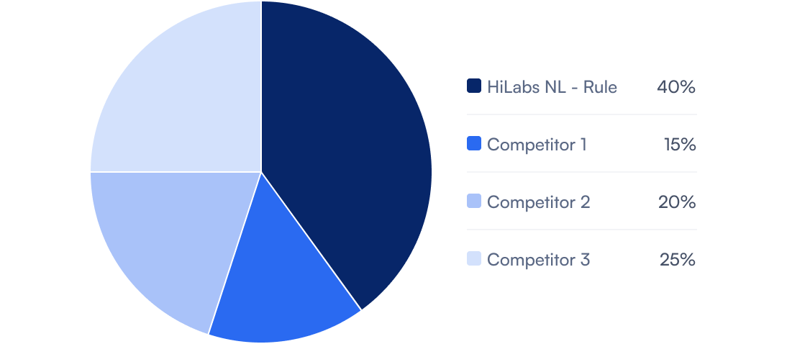
[Image Caption] Overall User Experience Comparison: Leading Rule Engines at a Glance

The HiLabs NL-to-Rule Engine stands out with the highest user experience score, reflecting usability, healthcare domain focus, and NLP features. This supports empowerment of non-technical analysts, reducing technical bottlenecks, and contributing to a a user-friendly, healthcare-centric rule management experience.
Strategic Takeaway
The broader BRM landscape is filled with general-purpose tools that address enterprise scenarios but are less tailored to healthcare’s specialized, regulated environment. The HiLabs NL-to-Rule Engine redefines rule authoring as a human-centered, AI-supported process that emphasizes accuracy, transparency, and agility in healthcare data management.

Future Outlook
As rule volumes, data sources, and regulatory requirements continue to grow, healthcare organizations are likely to face increasing pressure to manage rule logic at greater scale and with tighter governance. Traditional approaches that depend heavily on specialized teams and manual workflows may become progressively harder to sustain.
Natural language–driven rule authoring, combined with domain-specific models and visualization, points toward a future in which rule management is more collaborative and transparent. Analysts, operations teams, and technical staff can share a common view of logic and intent while retaining necessary controls and audits.
In this context, solutions such as the NL-to-Rule Engine illustrate how AI capabilities can be applied to a focused operational problem—translating business intent into executable logic—while preserving the oversight required in healthcare.

Conclusion
The HiLabs NL-to-Rule Engine represents a paradigm shift in how healthcare rule authoring and data governance can be organized. Historically, rule creation has been constrained by technical complexity, cross-team dependencies, and the limitations of manual scalability. The approach described here addresses these challenges by combining AI-powered natural language interfaces with a human-centered design, aiming to provide both the precision of machine logic and the accessibility of user-led design.
This solution is not merely a process automation step; it is presented as an enabler of collaboration and operational efficiency. By empowering analysts, supporting communication across teams, and streamlining rule lifecycle management, the HiLabs NL-to-Rule Engine helps reduce the time and coordination required to deploy rule changes.
With the ability to interpret plain English instructions, visualize logic, and perform conflict and accuracy checks, the engine supports a more accessible model for healthcare rule management, helping organizations respond to shifting regulatory and business demands while maintaining accuracy, governance, or control.
As healthcare moves further toward data-driven, digital-first decision-making, the underlying rule-creation layer becomes increasingly important. The HiLabs NL-to-Rule Engine demonstrates one way to make this layer faster, more transparent, and more scalable.

